User Manual – You Might Dig

# **Contents**

Contents

[**Contents** 1](#_Toc492418073)

[**User Side** 2](#_Toc492418074)

[**Sign up** 2](#_Toc492418075)

[**Sign in** 4](#_Toc492418076)

[**Browse games** 5](#_Toc492418077)

[**See recommendations** 6](#_Toc492418078)

[**Set favourite genres and characteristics** 7](#_Toc492418079)

[**Admin Side** 8](#_Toc492418080)

# **User Side**

## **Sign up**

To sign up to the site, first tap the hamburger menu in the top right, then tap Sign Up

|  |  |
| --- | --- |
| IMG_2909.PNG | IMG_2911.PNG |

Then input an email address and password, and tap Sign Up

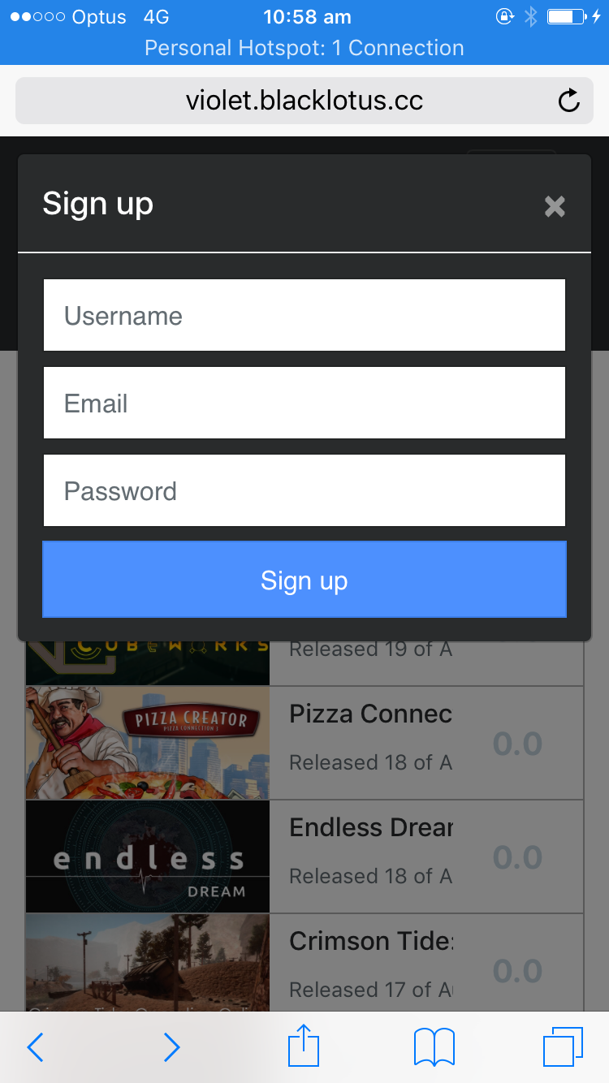

## 

## 

## **Sign in**

First tap the hamburger menu in the top right, then tap Sign In.

|  |  |
| --- | --- |
| IMG_2909.PNG | IMG_2911.PNG |

## **Browse games**

First tap the hamburger menu in the top right, then tap Browse.

|  |  |
| --- | --- |
|  |  |

Enter a search term in the box and tap Search

|  |  |
| --- | --- |
|  |  |

## **See recommendations**

Prerequisite: that you have set some favourite genres and characteristics.

Sign in first (see previous section). Then tap the hamburger icon, then “View Recommendation”.

|  |  |
| --- | --- |
|  |  |

To see a new recommendation, tap “Next Recommendation”.

|  |  |
| --- | --- |
|  |  |

## **Set favourite genres and characteristics**

Sign in, tap the hamburger icon, tap your user name, then go to Settings. Choose some genres and characteristics and press Save Preferences to save.

|  |  |
| --- | --- |
|  |  |

# **Admin Side**

To enter the administrator settings, click your login, then from the dropdown select “Admin”. You will then enter the default admin overview page, where you can see the overview of games, users, genres, characteristics and ratings.

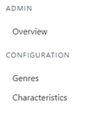

On the left-hand side of the page, there are three pages that you can navigate to. The default overview page, Genres management and Characteristics management. To change pages simply click on the text.

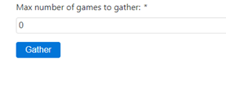

**·**  **Gather**

On the default overview page, there is an input box that allows you to manually set the max number of games that the system will gather. Simply enter a number and click the Gather button.

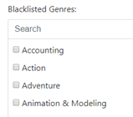

**· Manage genres**

To manage the genres, select the Genres page from the navigation bar on the left-hand side of the screen.

Blacklisted Genres - Once on the Genres page you can tick each box for each genres you wish not to be gathered.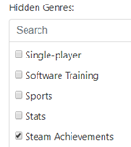

Hidden genres - Under the black listed genres there is the same setup to manage the hidden genres. Tick a box next to a genre you wish to be gathered, but a user not to be able to view.

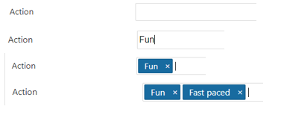

**· manage characteristics**

Select the characteristics option from the left-hand side menu bar. This page will allow you to assign the different rateable values a genre will have. E.g. the “Racing” genre might need to be rated for “Realism”, whereas a “RPG” does not need to be rated for realism as it would be fictional. To give a Genre a characteristic, click the text box next to the genre e.g. Action. Then type a characteristic you want to represent that genre e.g. Fun. Then hit enter to confirm. To remove a genre hit the small cross next to the characteristic. To add multiple just repeat the process, typing the next on after the last.